**Tuan Reza Samath**



**tuanrezasamath@gmail.com**

**Contact No. 077 8856394**

***OBJECTIVE: To pursue a challenging and creative career at an organization that offers motivation, personal growth, advancement, opportunity and stability.***

***PERSONAL DETAILS***

***Date of Birth : 24.08.1959***

***Gender : Male***

***Religion : Islam***

***Nationality : Sri Lankan Malay***

***Address : 96/1, Makola North, Makola, Sri Lanka***

***Civil Status : Married***

***Educational Qualifications : G.C.E. (Ordinary Level) Examination 1977***

***Other Qualifications : Followed an English Diploma at Gainsborough English School.***

***PROFESSIONAL EXPERIENCE*** 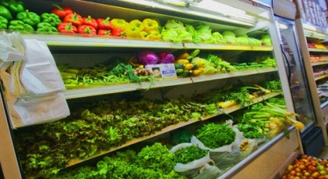

***Company - Yammine Super Market (in Lebanon)***

**Tenure -1982 – 1984**

**Designation -Salesman, Cum Supervisor**

**Job functions - To check on all frozen products & dairy products on daily, weekly & monthly basis depending on the product's expiry dates, ordering products according to the sales movement to minimize wastage also to increase company profitability.**

**Company - Spinney’s (Dubai) U.A.E. (The largest super market chain in the Middle East)**

**Tenure - 1987-1996**

**Work performed - joined as a shelf filler (counter filling) in almost all area except meat & cheese, the position held was senior salesman, responsible ordering goods though the system, maintaining stock levels, also meeting supplies with regard to the sales.**

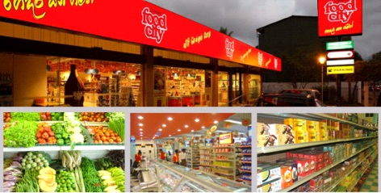**Company Name- Cargill's Ceylon (Pvt) Limited (Currently over 100 stores) leading super market chain in Sri Lanka.**

**Tenure - 1996-2004**

**Designation - Senior Manager**

**Work Performed**

* **As super market Manager Responsible for the operation and the administration.**
* **To carry out the company policies, Procedures and maintain the company standards.**
* **Responsible for maintaining the stock holding within the stipulated limit of 14 days ensuring availability of products.**
* **Briefing and communicating to staff on daily basis staff discipline, maintaining.**
* **Ensuring the cleaning procedures, House Keeping in all area of the super market personal hygiene.**

**In Europe - From 2004 – 2008 in France & Italy**

**Present Job**

**Company Name - Hameedia (Pvt) Ltd. (Sri Lankan's Number one men's – wear specialist)**

**Tenure - Since 2009**

**Designation - Branch Manager**

**Job Functions - To ensure the product availability, visual merchandising to monitor on daily basis, in house training on products & visual weekly, monthly basis, daily staff briefing on sales & other related issues which helps to increase the sales directly and indirectly.**

**REFERENCE**

* **ChannaJayasinghe 2. Mr. C.M.S.M. Rafeek**

**Brand Development Manager (Justice of Peace)**

**Kelani Cables (Pvt) No. 99/2, 8**

**P.O. Box 14, Wewelduwa, Makola North,**

**Dalugama. Makola.**

**Tel : 077 788015 Tel : 072 3262074**

**EXPECTED SALARY RS: 40.000**

**N.B. My retirement which will take effect from 31st December 2014 from present place working at (Hameedia)**

**I do hereby certify that the above particulars are true and accurate to the best of my knowledge.**

**Thank you.**

**Yours truly,**

**………………………**

**T. Reza Samath**